## What is Continuity?

In general terms, continuity is when a function has *no gaps, holes, or breaks*. There are three different types of continuity however.

## 3 Types of Continuity?

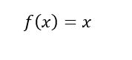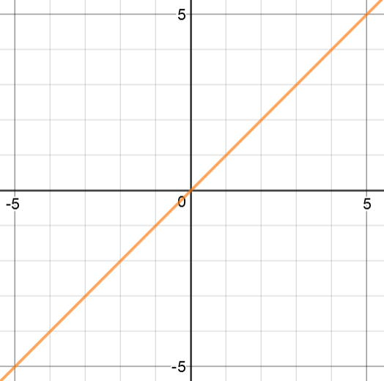At a point

$f(x)$ is continuous at $x=\frac{1}{2}$ $g(x)$ is not continuous at $x=\frac{1}{2}$

because $f(1/2)$ is not defined

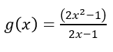For f to be continuous at $x=c$,

* $f(c)$ must be defined
* $\lim_{x→c}{f\left(x\right)}$ exists



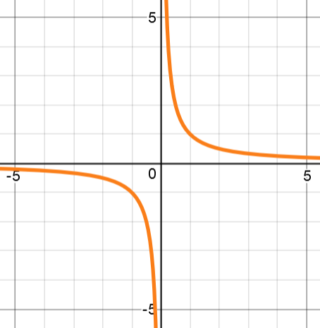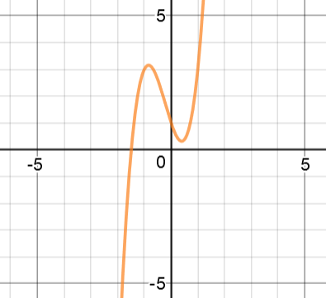Over an open interval

For f to be continuous over (a, b), f must be continuous at every point in (a,b)

$f(x)$ is continuous over (-2,2) $g(x)$ is not continuous over (-2,2)

Because $f(x)$ is not continuous at x = 0

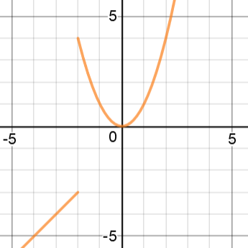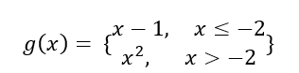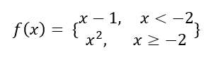Over a closed interval

For f to be continuous over [a,b],

* $f(x)$ must be continuous on (a,b)

$\lim_{x→a^{+}}{f\left(x\right)}=f(a)$

$\lim_{x→b^{-}}{f\left(x\right)}=f(b)$

$f(x)$ is continuous over [-2,2] $g(x)$ is not continuous over [-2,2]

Because $\lim_{x→{-2}^{+}}{f\left(x\right)}≠f(-2)$

## What is a Discontinuity?

A discontinuity is a point within an interval where $f(x)$ is not continuous. There are two types of discontinuities: removable and non-removeable.

Removeable:

A removeable continuity, or a hole, can be fixed by redefining $f$ at just one point. This happens when $\lim_{x→c}{f(x)}$ exists but $f(c)$ does not exist or is not equal to the limit.

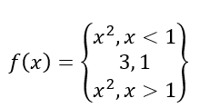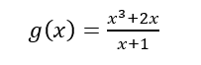Algebraically, if $f(c)$ leads to indeterminate form, a removeable discontinuity should occur at $x=c$.

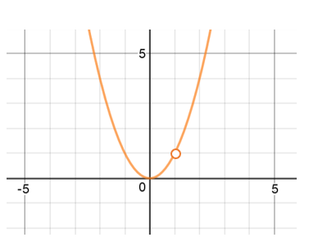

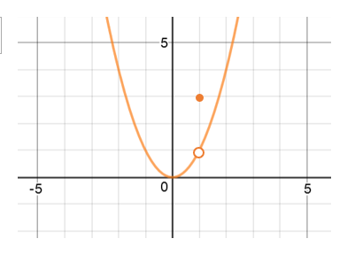

Both $g(x)$ and $f\left(x\right)$ have removeable discontinuity at x = -2, because making $f\left(-2\right)=1$ makes this function continuous

Non-removeable:

A non-removeable discontinuity cannot be removed by redefining $f\left(x\right)$ at one point. This happens when $\lim_{x→c}{f(x)}$ does not exist, and $f(c)$ either does or does not exist. If $f\left(c\right)=\frac{a}{0}$ there is a non-removeable discontinuity.

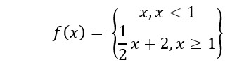

## The Squeeze Theorem

If $h\left(x\right)≤f\left(x\right)≤g\left(x\right)$ for all x in an open interval containing c, except possibly at c itself, and if $\lim_{x→c}{h\left(x\right)=L=\lim_{x→c}{g(x)} }$ then $\lim_{x→c}{f(x)}$ exists and is equal to L.

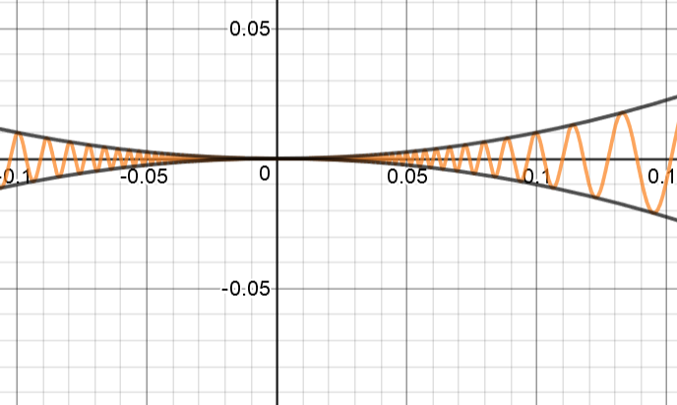In general terms: If a function is between 2 other functions that share a limit then the function will share the same limit. $h\left(x\right)= -x^{2} f\left(x\right)=x^{2}\cos\left(\frac{5}{x}\right) g\left(x\right)=x^{2}$

$$f$$

$$g$$

$$h$$

$\lim_{x→c}{f\left(x\right)=0}$ 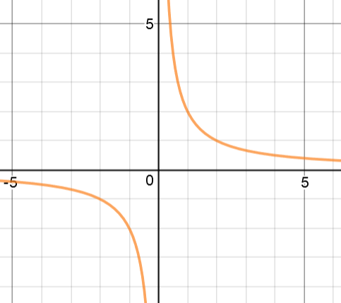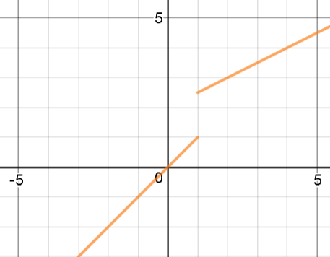 according to the squeeze theorem

$f\left(x\right)$ has a non-removable discontinuity at $x=1$ $g(x)$ has a non-removable discontinuity at $x=0$

because $\lim_{x→1}{f\left(x\right)}=DNE$ because $\lim_{x→0}{f\left(x\right)}=DNE$

## Intermediate Value Theorem

*If $f$ is continuous on the closed interval $[a, b]$ and $k$ is any number between $f\left(a\right)$ and $f(b)$ then there is at least one number $c$ in $[a,b]$ where $f\left(c\right)=k$*

The IVT can guarantee that a function reaches a certain height over an interval based on its endpoints

Example of how the IVT could be used:

Use the IVT to show that $f\left(x\right)=3x^{3}+2x^{2}-5x$ has a zero in [-2,2]

$f$ is a polynomial so it is continuous

$f\left(-2\right)= -6$

$f\left(2\right)=22$

$f\left(-2\right)<0<f(2)$ so there exists a c such that $f\left(c\right)=0$